Lesson Plan
Semester: V Year: 2023-2024
Course Title: Artificial Intelligence and Machine Learning | Course Code: 21AI52
Total Contact Hours: 45 L:T:P : 03:00:01 | Duration of SEE: 3 hrs
SEE Marks: 150 | CIE Marks: 150
Lesson Plan Author: Dr Soumya A, Dr Shanta R, Dr Suma Rao B | Date: 10.10.2023
Checked By: | Date:

Course Overview:
This course is basically used in E-commerce applications and all applications related to Computer Science domain

Course Outcomes(CO): After completing the course, the students will be able to
Explain and apply AI and ML algorithms to address various requirements of real-world problems.
Design and develop AI and ML solutions to benefit society, science, and industry.
Use modern tools to create AI and ML solutions.
Demonstrate effective communication through team presentations and reports to analyze the impact of AI and ML solutions on society and nature.
Conduct performance evaluation, modeling, and validation of AI and ML solutions benefiting lifelong learning.

Course Content
UNIT – I  Introduction: What is AI?  Intelligent agents: Intelligent Agents: Agents and environment; Rationality; the nature of environments; the structure of agents  Problem Solving & Uninformed Search Strategies: Problem-solving agents, Breadth-first Search, Depth-first Search, Depth-limited Search and Iterative Deepening Depth First Search | 09 Hrs.
UNIT – II  Informed (Heuristic) Search Strategies: A* Search, Heuristic Functions  Beyond Classical Search: Local Search Algorithms and Optimization Problems, Hill-climbing Search, Simulated Annealing, Local-beam Search, Genetic Algorithms  Adversarial search: Games, Optimal decision in games, Alpha-Beta Pruning | 09 Hrs.
UNIT-III  Supervised Learning: Basic Concepts, General Framework for Classification  Decision Tree Classifier-A Basic Algorithm to Build a Decision Tree, Methods for Expressing Attribute Test Conditions, Measures for Selecting an Attribute Test Condition, Algorithm for Decision Tree Induction, Characteristics of Decision Tree Classifiers,  Model Overfitting- Reasons for Model Overfitting  Model Selection - Using a Validation Set, Incorporating Model Complexity, Estimating Statistical Bounds, Model Selection for Decision Trees, Model Evaluation | 09 Hrs.
UNIT –IV  Nearest Neighbor Classifiers-Characteristics of Nearest Neighbor Classifiers  Naive Bayes Classifier-Basics of Probability Theory, Naive Bayes assumption  Logistic Regression-Logistic Regression as a Generalized Linear Model, Learning Model Parameters, Characteristics of Logistic Regression  Ensemble Methods – Methods for constructing Ensemble classifier, Bagging, Boosting, Random Forests | 09 Hrs.
UNIT – V  Unsupervised Learning- Overview, What Is Cluster Analysis, Different Types of Clustering’s, Different Types of Clusters  K-means-The Basic K-means Algorithm, Additional Issues, Bisecting K-means, K-means and Different Types of Clusters, Strengths and Weaknesses, K-means as an Optimization Problem  Cluster Evaluation-Overview, Unsupervised Cluster Evaluation Using Cohesion and Separation, Unsupervised Cluster Evaluation Using the Proximity Matrix, Determining the Correct Number of Clusters, Supervised Measures of Cluster Validity, Assessing the Significance of Cluster Validity Measures, Choosing a Cluster Validity Measure | 09 Hrs.
Reference Books
1. | AI – A Modern Approach ,Stuart Russel, Peter Norvig, 3rd Edition, 2010, Pearson, ISBN-13: 978-0136042594
2. | Artificial Intelligence Basics: A Self Teaching Introduction, Neeru Gupta and Ramita Mangla, Mercury Learning and Information, 1st Edition, 2020, ISBN: 978-1-68392-516-3.
3. | Machine Learning ,Tom M. Mitchell, Indian Edition, 2013, McGraw Hill Education, ISBN – 10 – 1259096955
4. | Introduction to Data Mining ,Pang-Ning Tan, Michael Steinbach, Vipin Kumar,2nd edition, 2019,Pearson , ISBN-10-9332571406, ISBN-13 -978-9332571402

Unit and Chapter wise Plan
Unit I
Chapter Number and Title: Chapter-1 Introduction; Chapter-2 Intelligent Agents; Chapter-3 Solving Problems by Searching (Textbook No.: AI – A Modern Approach ,Stuart Russel, Peter Norvig) | Planned Hours: 09

Learning Objectives:
Sl. No. | Objectives
1 | To appraise the need of Artificial Intelligence, Intelligent Agents, and Various working environments of agents with the models
2 | Some of the uninformed search strategies are to be discussed with algorithms, and efficiencies

Lesson Schedule
Class No. | Portion covered per hour
1 | AI, its importance, applications, etc.
2 | Intelligent Agents
3 | Agent Environments,
4 | Structure of Agents
5 | Problem solving Agents
6 | BFS & DFS,
7 | Depth-limited Search
8 | Iterative Deeping Depth First Search
9 | Summary

Model Questions

A rational agent produces the best outcome when there is a situation of uncertainty. By considering an agent which is designed for driverless cars, discuss any three possibilities of uncertainty and also how agent’s rationality could help in handling those possibilities.
A chatbot is an artificial intelligence (AI) software that can simulate a conversation (or a chat) with a user in natural language through messaging applications, websites, mobile apps or through the telephone. Give a PEAS description of a chatbot which is used to promote the cultural event in a college.
Mention the types of environments suitable for the following tasks and justify your selection;
- Agent monitoring the temperature of the boiler in a manufacturing plant.
- Agent detecting network attacks
- Robot navigation
- Radiology images analysis
- Cab aggregation agent
Searching is an important requirement for developing goal-based agents, by considering an example of 4-queens problem, discuss the same.
Formulate AI problem (includes States, initial state, actions, transition model, goal test, path cost) for an agency which sells Ayurvedic medicines online.
Transactional bots allow customers to make a transaction within the context of a conversation. In the financial sector, they can automate simple tasks such as verifying your identity, blocking your stolen credit card, giving you the working hours of nearby branches or confirming an outgoing transfer. Give a PEAS description of a transactional bot used in financial sector.
A rational agent produces the best outcome when there is a situation of uncertainty. By considering an agent used to recommend buying a small house close to the city-center or buying a bigger house in a suburb area of the city, discuss any three possibilities of uncertainty and also how agent’s rationality could help in handling those possibilities.
Consider an agent that uses e-commerce sites for shopping for used electronic gadgets. Give the PEAS description for this. What are the properties of task environment? Give one example for each.
Consider the 8-puzzle problem:
Start state:
2 | 8 | 3
1 | 6 | 4
7 |  | 5

Goal state:

1 | 2 | 3
8 |  | 4
7 | 6 | 5

Generate the state space and apply DFS and BFS algorithm to find the goal state.

Unit II
Chapter Number and Title: Chapter-3 Solving Problems by Searching; Chapter-4 Beyond Classical Search; Chapter-5 Adversarial Search (Textbook No.: AI – A Modern Approach ,Stuart Russel, Peter Norvig) | Planned Hours: 09

Learning Objectives:
Sl. No. | Objectives
1 | To understand the working principles of some of the informed search strategies
2 | To understand the advantageous of new types of searching techniques against classical search techniques

Lesson Schedule
Class No. Portion covered per hour

Class No. | Portion covered per hour
1 | Working of A* Search
2 | Application of Heuristic functions in searching and linked with AI
3 | Local search algorithms & Optimization Problems
4 | Hill-climbing Search
5 | Simulated Annealing
6 | Local-beam search and GA
7 | Games
8 | Optimal Decision in Games
9 | Alpha-Beta Pruning

Model Questions

Prove by considering an example, the greedy best-first search is an incomplete search even with finite number of states.
A Heuristic can be simply defined as a function that estimates how close a state is to a goal. By considering a 8-puzzle problem justify this statement.
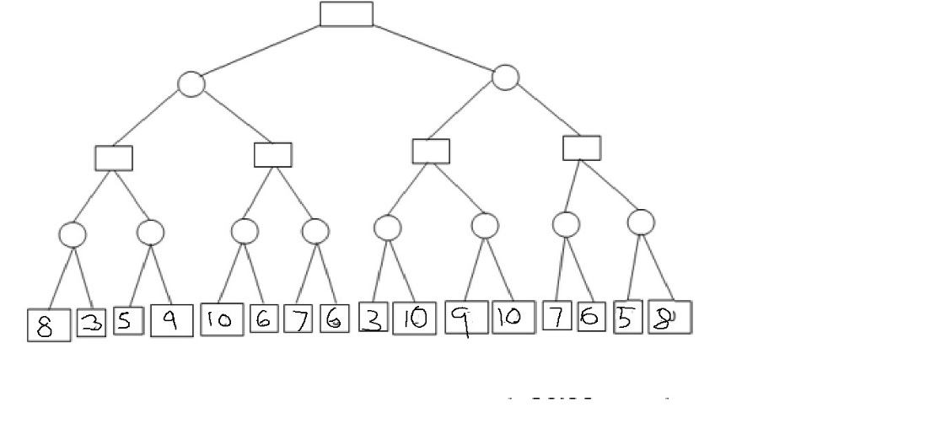
Apply Alpha-Beta pruning on the given game tree to solve min-max problem. Assume root as MAX node.
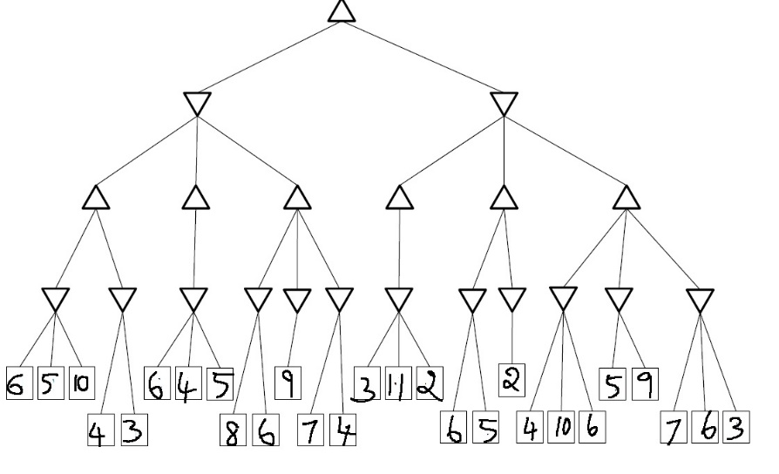
Apply Alpha-Beta pruning on the given game tree to solve min-max problem. Assume root as MAX node.
Consider the below graph and apply Best First Search algorithm where A is start state and J is the goal state. Show the contents of open/frontier list and closed list at each step.

The value given with nodes are the heuristics value.
Apply A* algorithm to the below given blocks problems:
Start State:
–3 | A
+2 | B |  | D | –2
+1 | C |  | E | +1
Goal state:

+4 | A
+3 | D
+2 | B
+1 | C |  | E | +1

Heuristics H(n) = Add 1 for every block in correct structure that the block is sitting on and subtract 1 for every block not in structure.
Write simulated Annealing Algorithm, and discuss its working by considering an example for optimization
Explain the working of hill-climbing search, and discuss its merits and limitations.
Discuss the concept of Game Trees. With an example Game Tree illustrate the application of AI in games.

Unit III
Chapter Number and Title: 03: Chapter 3 :Supervised Learning, Decision Tree Classifier, Model Selection, Model Over fitting(Text Book: Introduction to Data Mining ,Pang-Ning Tan, Michael Steinbach, Vipin Kumar) | Planned Hours: 09

Learning Objectives:
Sl. No. | Objectives
1 | To apply the concepts of Supervised Learning in different computer science applications
2 | To analyze between Model Selection and Model Overfitting
3 | To evaluate and demonstrate the supervised Learning Algorithms for a given problem scenario

Lesson Schedule
Class No. | Portion covered per hour
1 | Basic Concepts, General Framework for Classification
2 | A Basic Algorithm to Build a Decision Tree
3 | Algorithm for Decision Tree Induction,
4 | Characteristics of Decision Tree Classifiers
5 | Measures for Selecting an Attribute Test Condition
6 | Methods for Expressing Attribute Test Conditions,
7 | Reasons for Model Overfitting
8 | Using a Validation Set, Incorporating Model Complexity,
9 | Estimating Statistical Bounds, Model Selection for Decision Trees, Model Evaluation

Model Questions
- Discuss the General Framework of Classification
- Discuss the characteristics of Decision Tree Classifiers
- Discuss the reasons for model overfitting
- Discuss any two methods for Model Evaluation

Unit IV
Chapter Number and Title: 04: Chapter – 6 Nearest Neighbor Classifiers, Naive Bayes Classifier, Logistic Regression, Ensemble Methods(Text Book: Introduction to Data Mining ,Pang-Ning Tan, Michael Steinbach, Vipin Kumar) | Planned Hours: 09

Learning Objectives:
Sl. No. | Objectives
1 | To apply the use of supervised algorithms for different computer science applications
2 | To analyze different supervised algorithms to solve real world problems
3 | To evaluate the concepts of Supervised algorithms in real world problems

Lesson Schedule
Class No. | Portion covered per hour
1 | Algorithm, Characteristics of Nearest Neighbor Classifiers
2 | Basics of Probability Theory
3 | Naive Bayes assumption
4 | Logistic Regression as a Generalized Linear Model
5 | Learning Model Parameters
6 | Characteristics of Logistic Regression
7 | Characteristics of Logistic Regression
8 | Methods for constructing Ensemble classifier
9 | Bagging, Boosting, Random Forests

Model Questions
- Discuss k-nearest neighbor classifier and gives its characteristics
- Discuss Naïve Bayes Classifier
- Discuss Logistic Regression
Unit V
Chapter Number and Title:5 Chapter- 5 Unsupervised Learning, K-means, Cluster Evaluation(Text Book: Introduction to Data Mining ,Pang-Ning Tan, Michael Steinbach, Vipin Kumar) | Planned Hours: 09

Learning Objectives:
Sl. No. | Objectives
1 | To apply the concepts of Unsupervised Learning for different computer science applications
2 | To analyze concepts Unsupervised Learning to solve real world problems
3 | To evaluate the concepts Unsupervised Learning in real world problems

Lesson Schedule
Class No. | Portion covered per hour
1 | Overview, What Is Cluster Analysis
2 | Different Types of Clustering’s, Different Types of Clusters
3 | The Basic K-means Algorithm, Additional Issues, Bisecting K-means
4 | K-means and Different Types of Clusters, Strengths and Weaknesses
5 | K-means as an Optimization Problem
6 | Unsupervised Cluster Evaluation Using Cohesion and Separation
7 | Unsupervised Cluster Evaluation Using the Proximity Matrix
8 | Determining the Correct Number of Clusters ,Supervised Measures of Cluster Validity
9 | Assessing the Significance of Cluster Validity Measures, Choosing a Cluster Validity Measure

Model Questions
- What do you mean by cluster analysis and discuss about different types of clustering
- Explain Basic K-means clustering and issues related to it
- What are the different types of cluster evaluation
- What do you mean by cluster tendency

Evaluation Scheme

Continuous Internal Evaluation (CIE)
( Theory – 100 Marks)
Evaluation method | Marks
Quiz -1 | 10
Test -1 | 50
Quiz -2 | 10
Test-2 | 50
Improvement Quiz | 10
Improvement Test | 50
EL | 40
Total Quiz | 20
Total Test | 40
Total – theory | 100 (20+40+40)
Experiential Learning Details

Students should develop a Machine Learning model on the problem statements chosen from Agriculture, Health Care, Manufacturing, and Process Control/Automation Domains related to Indian Scenarios.
- The data collected should be cleansed and pre-processed.
- The complete EDA process has to be demonstrated
- Selection of the suitable algorithms and model-building
- Model evaluation has to be carried out by selecting the proper metrics
- Prediction/classification results have to be obtained and should be demonstrated through visualizations and GUI

Semester End Evaluation Theory (100)
Part- –A  Objective type questions | 20
Part –B  There should be five questions from five units. Each question should be for maximum of 16 Marks.  The UNIT-1 is compulsory  The UNIT-2,UNIT-3,UNIT-4 and UNIT-5 should have internal Choice  Both the questions should be of the same complexity in terms of COs and Bloom’s taxonomy level. | 80
Total | 100
Course Articulation Matrix (3: High 2: Medium 1: Low)

CO-PO Mapping
CO/PO | PO1 | PO2 | PO3 | PO4 | PO5 | PO6 | PO7 | PO8 | PO9 | PO10 | PO11 | PO12
CO1 | 1 | -- | -- | -- | -- | -- | -- | -- | -- | -- | -- | --
CO2 | -- | 1 | 1 | -- | -- | -- | -- | -- | -- | -- | -- | --
CO3 | -- | -- | -- | -- | 1 | -- | -- | -- | -- | -- | -- | --
CO4 | -- | -- | -- | -- | -- | -- | -- | -- | -- | 2 | -- | --
CO5 | -- | -- | -- | -- | -- | -- | -- | -- | -- | -- | -- | 1
CO –PSO Mapping
CO/PSO | PSO1 | PSO2
CO1 | 1 | --
CO2 | 1 | --
CO3 | -- | 1
CO4 | -- | 2
CO5 | 1 | --

Innovative teaching method/s used

Sl.No | Type | Purpose
1 | Flipped Class Room | To Learn the different concepts of AIML
2 | Project Based Learning | To develop the analytical and logical skills and build team work

Name of the faculty with Sign. HOD

